Theme  The Romans  We will be learning about Roman daily life and what the Romans gave us.  Research one of the following explaining how it helps us today.  Plumbing (central heating and the toilet), roads, the calendar or aqueducts.  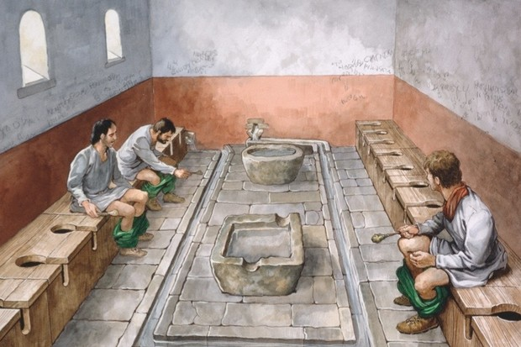 | French  Les calendrier des Fetes  There are many french festivals that are celebrated all over France.  Create a poster for a French festival. For example:  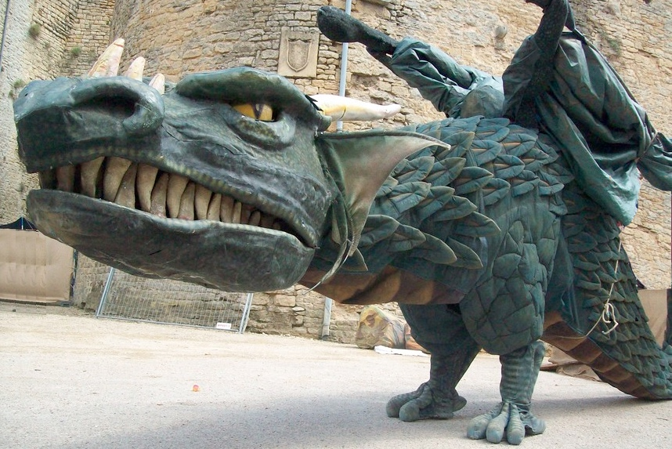  Bastille Day, Nice Carnival,Festival Medieval de Sedan, Festival of Lights. | Reading  We are reading The Boy in the Dress by David Walliams.  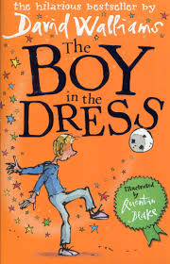  Write down 5 questions you would like to ask him about this book, other books he has written that you have read or general questions about what it’s like being a writer.
ART  Perfect Pom poms  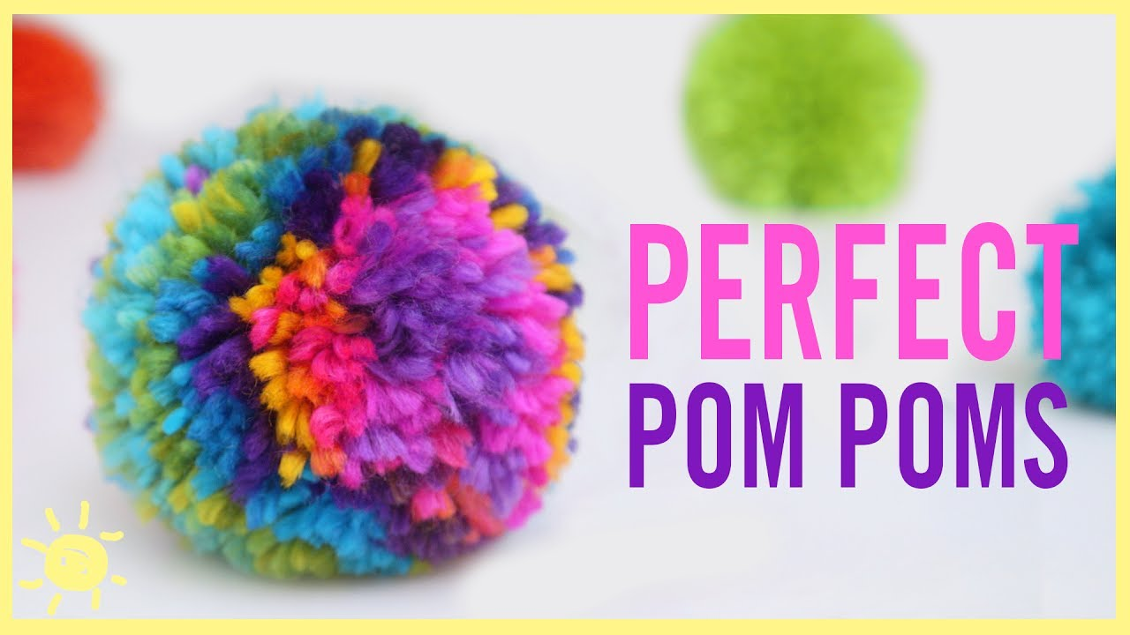  We are going to make pom poms for our pen pals at the nursing home. Have a go at home and we can make some to sell at the Christmas fair too. | Literacy  Dennis (the main character in The Boy in the Dress) likes fashion magazines. Research and write a biography about a famous fashion designer.  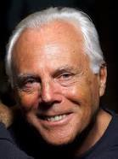  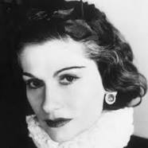  A biography is a description of a real person's life.  Coco Channel Giorgio Armani Marc Jacobs | R.E  We are thinking about the question  What is Trinity?  This is the idea that three different people are all called God.  Draw someone you know who has more than one role.  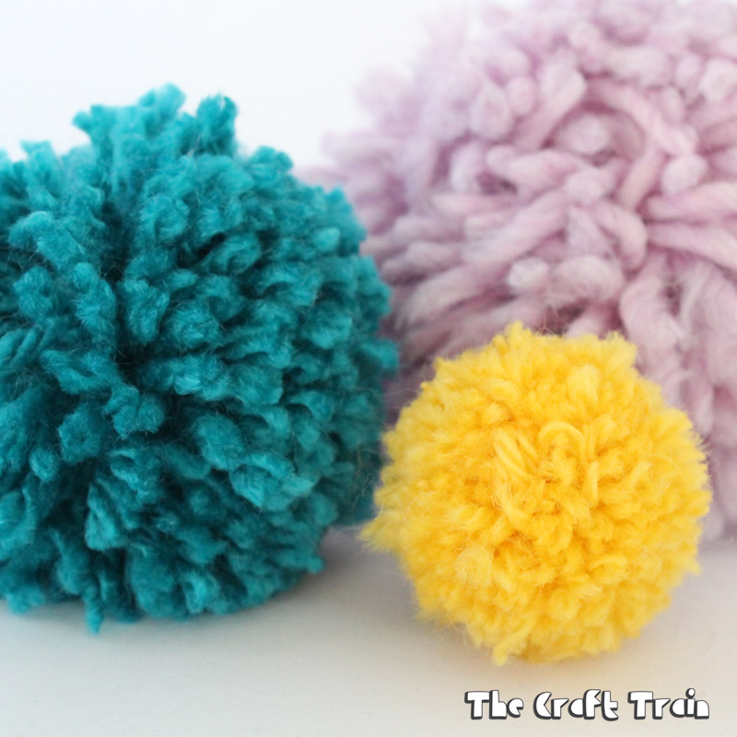  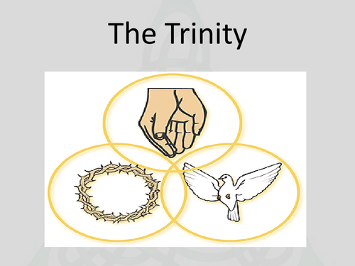  For example: mum is a mum, wife and sister.
Science  We will be learning about animals and humans.  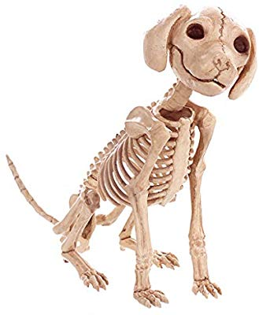  Choose an animal skeleton and label the bones it has. | PSHE  E-Safety  We are learning about how to stay safe on the internet.  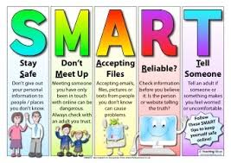  Create a poster for staying safe on the internet. | Maths  Multiplication and Division  Create a maths game (snap, a board game) to help someone with learning their times tables and division facts.

